9th June 2022

Dear Parents and Carers

As you are aware, our beloved caretaker, Mr Maddy, unfortunately lost his battle with cancer and passed away in May. He had worked at the school for many years and was a trusted and valued member of staff, who we all greatly miss.

We have decided to complete a sponsored run in memory of Mr Maddy, in the hope that the children can raise some funds to buy a memorial bench to place in the school grounds, by our pond area, which was a project he was instrumental in creating.

The route we would like the children to run is outlined on the map below. We do invite parents to come along and line the route, so that they can cheer the children on and offer support. The children will be running/walking a further distance than they have completed so far. However we would like to keep parental attendance as a surprise to the children, so as they leave the grounds, they witness the support unexpectedly. We hope this will help provide them such extra momentum.

Please see the times and dates of the event below. We ask that all children wear their PE kits on the day that they are completing the run.

We would really appreciate it if you could donate as little or as much as you can, via the payment item on ParentPay. Any remaining money donated will be given to Severn Hospice, where Mr Maddy spent his last few days of life.

Yours sincerely

Claire Whiting
Headteacher

Route Map and Timings

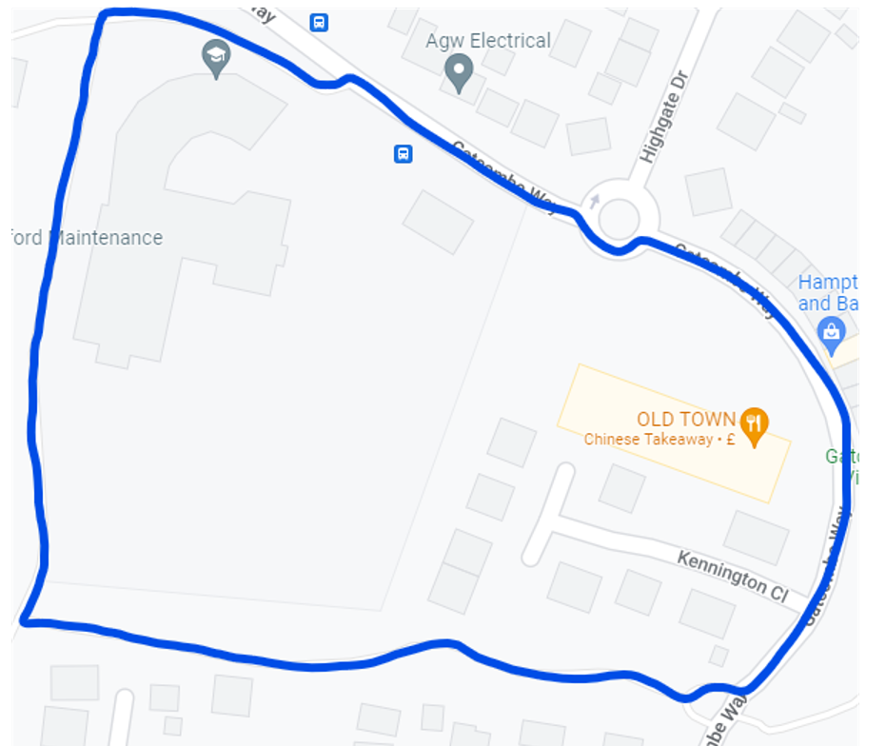

Monday 11th July (all children wear PE kit on this day)

9.00am Year 1 Exit main gates, enter side gate (1 lap)
9.05am Year 2 Exit main gates, enter side gate (1 lap)
9.10am Year 3 Exit main gates, enter side gate (2 laps)
2.20pm Nursery Exit main gates, enter side gate, walk, and run along the path behind the school
2.25pm Reception Exit main gates, enter side gate, walk, and run along the path behind the school

Wednesday 13th July (all children wear PE kit on this day)

9.00am Year 6 Exit main gates, enter side gate (3 laps)
9.05am Year 5 Exit main gates, enter side gate (3 laps)
9.10am Year 4 Exit main gates, enter side gate (2 laps)

